SQL Querries

#Q3 Which product categories drive the most revenue?

SELECT CategoryName, SUM(Quantity * Price) AS TotalRevenue
FROM Categories cat
JOIN Products p ON cat.CategoryID = p.CategoryID
JOIN OrderDetails od ON p.ProductID = od.ProductID
GROUP BY cat.CategoryName
ORDER BY TotalRevenue DESC;

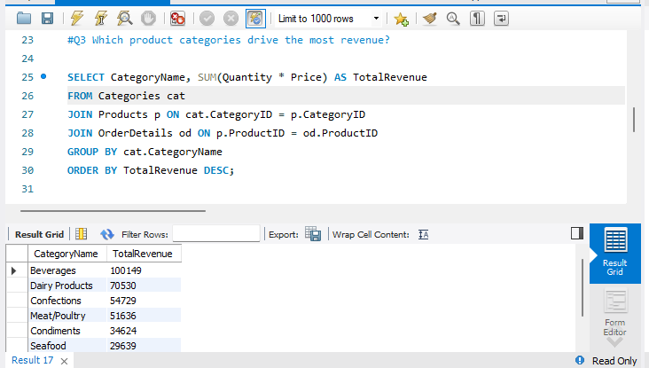

#Q4 Employee Performance
#Which employee handles the highest number of orders?
SELECT LastName FirstName, COUNT(o.OrderID) AS TotalOrders
FROM Employees e
JOIN Orders o ON e.EmployeeID = o.EmployeeID
GROUP BY LastName
ORDER BY TotalOrders DESC;
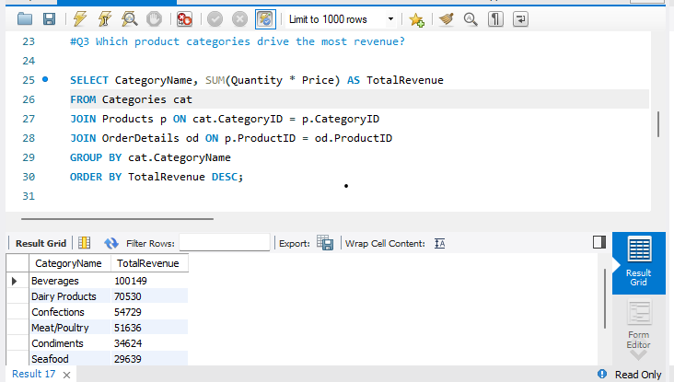

#Q5How does revenue vary by employee?

SELECT LastName, SUM(Quantity * Price) AS RevenueGenerated
FROM Employees e
JOIN Orders o ON e.EmployeeID = o.EmployeeID
JOIN OrderDetails od ON o.OrderID = od.OrderID
JOIN Products p on p.ProductID = od.ProductID
GROUP BY LastName
ORDER BY RevenueGenerated DESC;

